Chapter 4
Implementation
4.1 Web Application
The development of Patients Information Management System is used by doctors to keep and manage each patient’s information in order to help the doctors make decisions before diagnosis or surgery. The doctors can use the system through the web browser via tablets.
4.2 User Interface
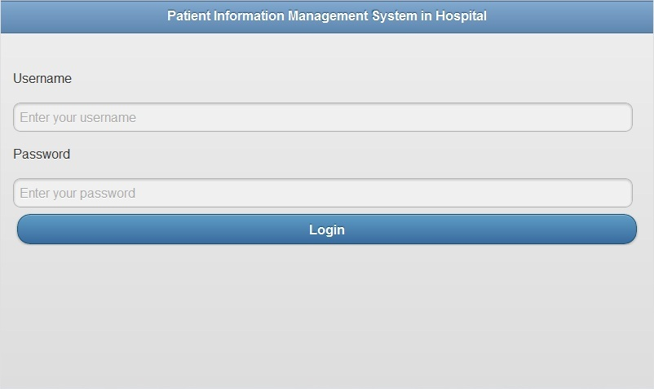
Figure 4.1 The first page of the web application
Figure 4.1 shows the first page of the web application. The doctor needs to log into the system by using a username and a password. If the username and the password are matched, the doctor is able to access to the system shown in Figure 4.2.
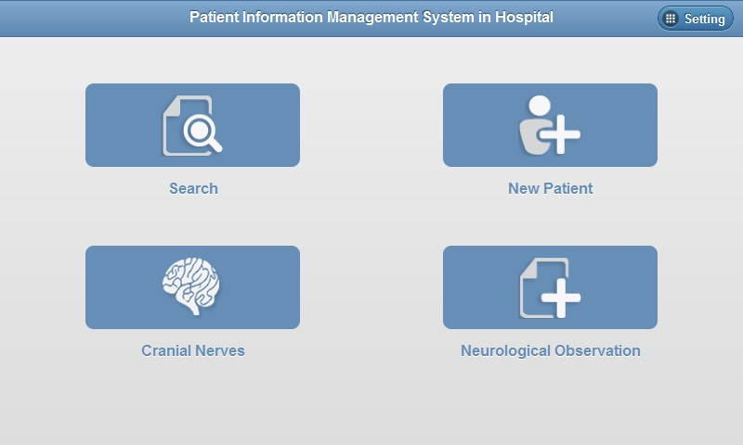
Figure 4.2 The index page of the web application
The index page shows the main functions of the web application which consists of search, new patient, cranial nerves and neurological observation.
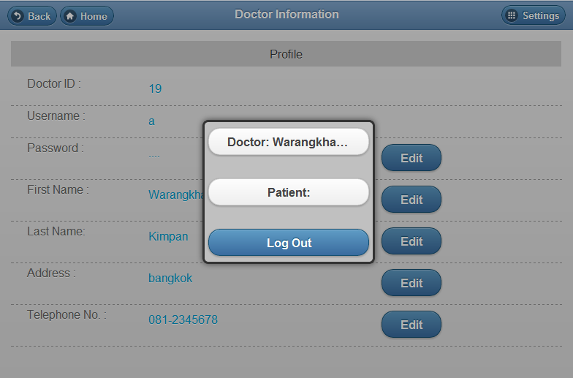
Figure 4.3 Setting
Figure 4.3 shows the setting on the navigation bar which provides the link to view the doctor’s profile, the patient’s profile and also log out from the system.
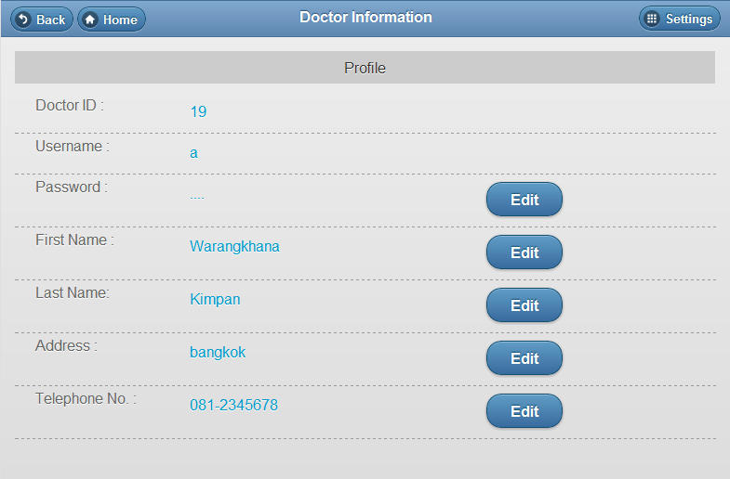
Figure 4.4 Doctor’s profile page
Figure 4.4 shows the doctor’s profile page which enables the doctor to edit his/her profile by pressing on  and  buttons in order to save the edited information.
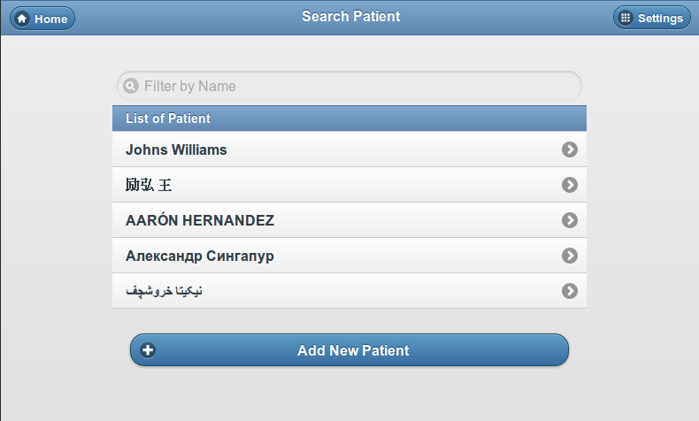
Figure 4.5 Search page
Figure 4.5 shows the search page where the doctor can search the patient’s profile in order to view a report or create a new record of cranial nerves or neurological observation. If the patient’s profile is not stored in the system, the doctor needs to create a new patient’s profile before creating a new record of cranial nerves or neurological observation as shown in Figure 4.6.
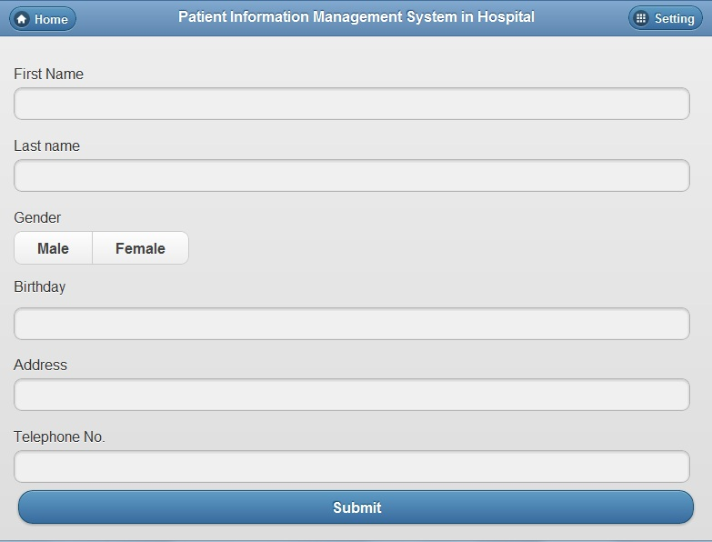
Figure 4.6 Create the new patient’s profile
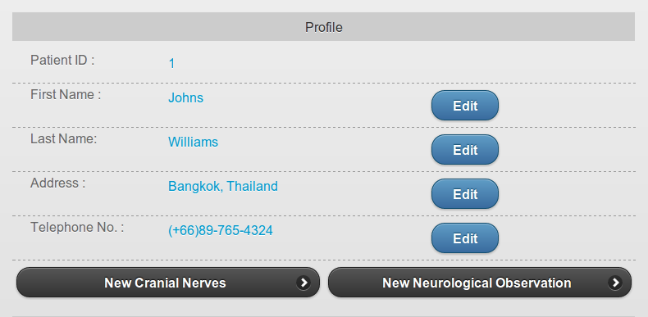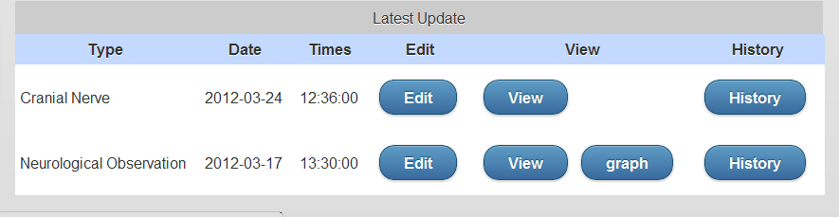
Figure 4.7 Patient information page
Figure 4.7 shows the patient’s information page which enables the doctor to edit the patient’s profile and create the new record of cranial nerves and neurological observation. The doctor can create a new record of cranial nerves by pressing on  button or  button in order to create a new record of neurological observation. The table below the patient’s profile shows the latest record of cranial nerves and neurological observation. The doctor can press  button to edit the old records, button to view the report, button in order to view the graph, and  button in order to view the history of records.
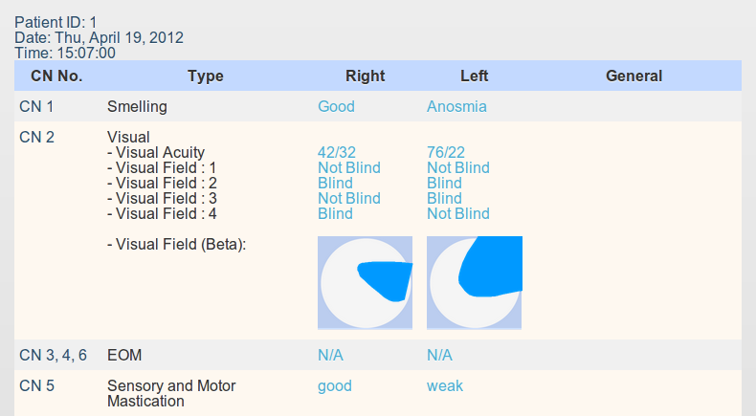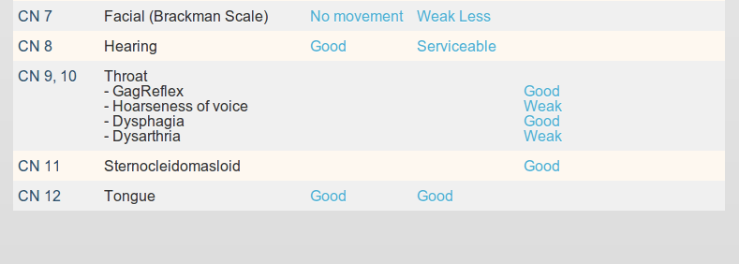
Figure 4.8 Cranial nerves report
Figure 4.8 shows the cranial nerves report of the selected time and date.
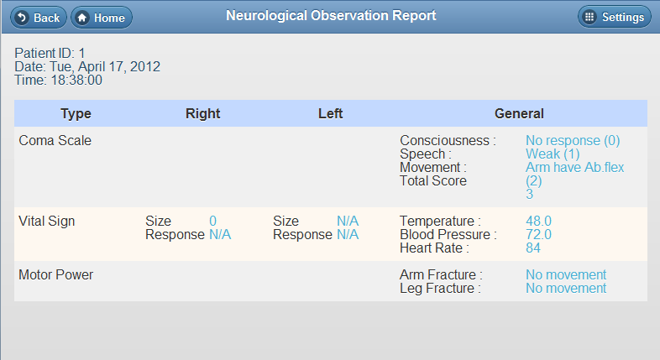
Figure 4.9 Neurological observation report
Figure 4.9 shows the neurological observation report of the selected time and date.
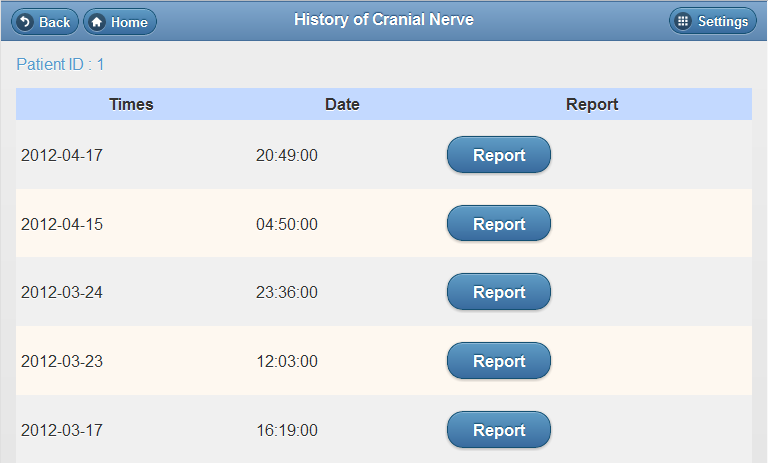
Figure 4.10 History of cranial nerves
Figure 4.10 shows the history of cranial nerves which the doctor can press the
button to view the report.

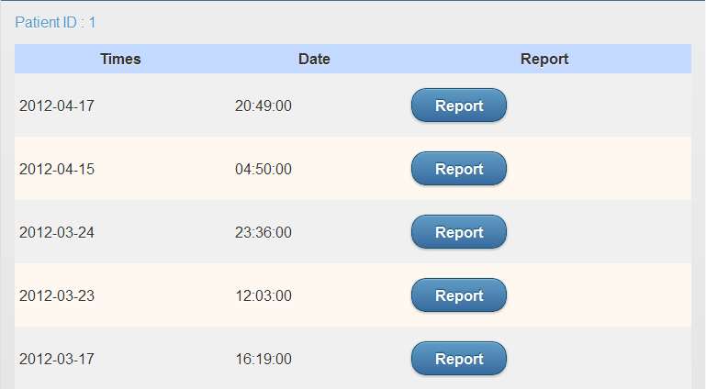
Figure 4.11 The history of neurological observation
Figure 4.11 shows the history of neurological observation which the doctor can press
button to view the report as graphs shown in Figure 4.12 and Figure 4.13.
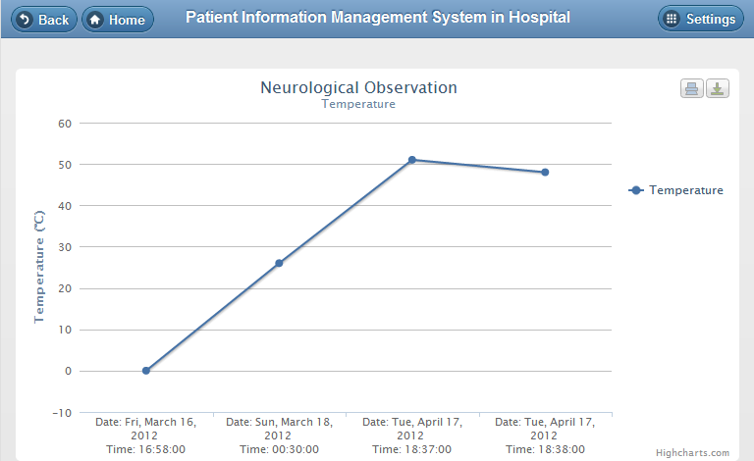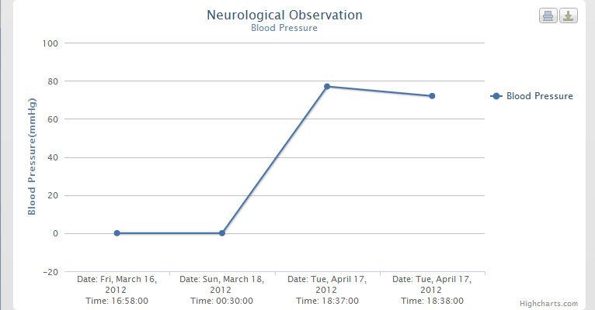
Figure 4.12 Temperature and blood pressure graphs
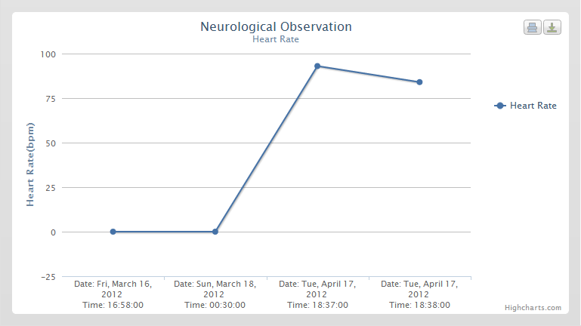
Figure 4.13 Heart rate graph
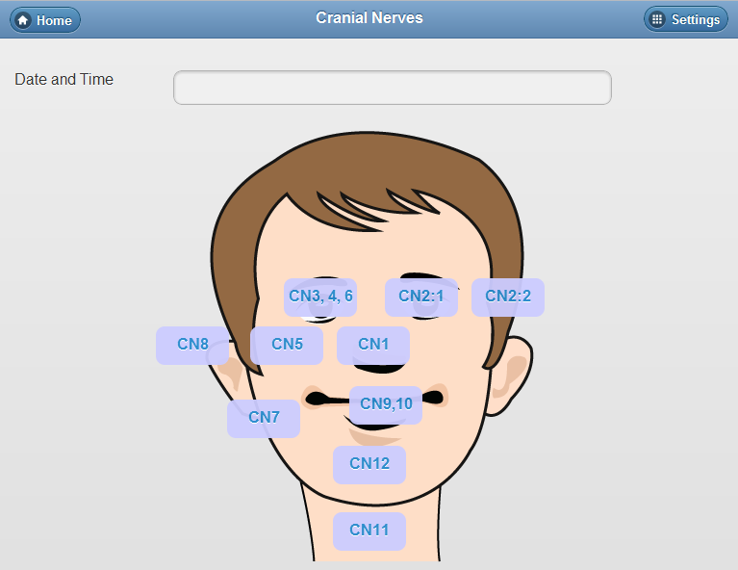
Figure 4.14 Main page of cranial nerves
Figure 4.14 shows the main functions of the web application which are used in recording the symptoms of twelve pairs of cranial nerves. The buttons on the man’s face indicate the positions of the cranial nerves where the doctor can link to the pages in order to record cranial nerves symptoms. The doctor needs to select date and time before recording the symptoms.
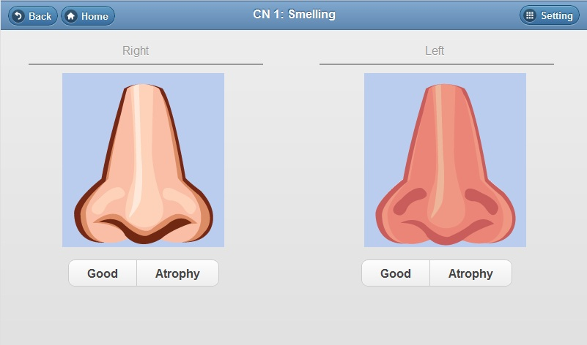
Figure 4.15 CN 1: Smelling
CN 1 in Figure 4.15 is shown about the sense of which is divided into left and right sides. The doctor can select one of the provided choices.
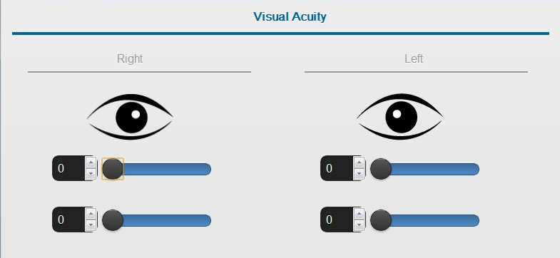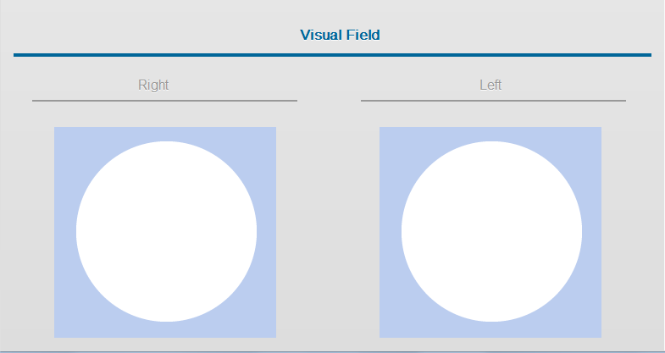
Figure 4.16 CN 2:1 Visualization
CN 2 in Figure 4.16 and Figure 4.17 are the transmission of visual signals from the retina of the eyes to the brain. It consists of two sections including visual acuity and visual field. In the visual acuity section, the doctor can slide the slider bars 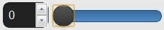 to fill in the values. In the visual field section, the doctor can press on the quarter of the circle where the abnormal occurred.
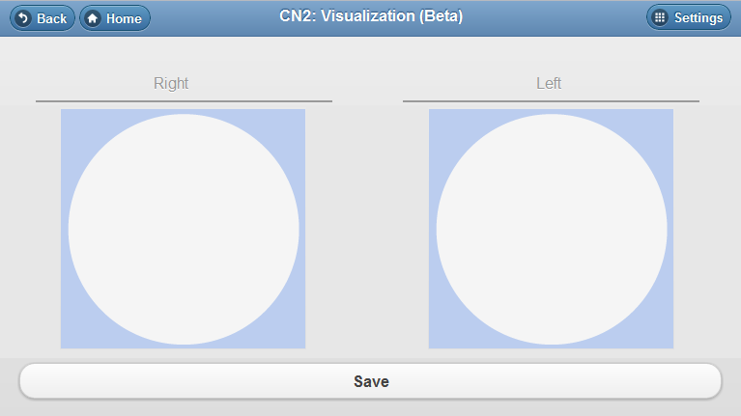
Figure 4.17 CN 2:2 Visualization
CN 2:2 in Figure 4.17 is the same as visual field in CN 2:1 but it allows the doctor to draw the blind position of the eyes.
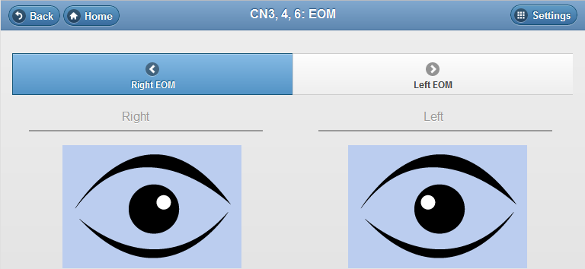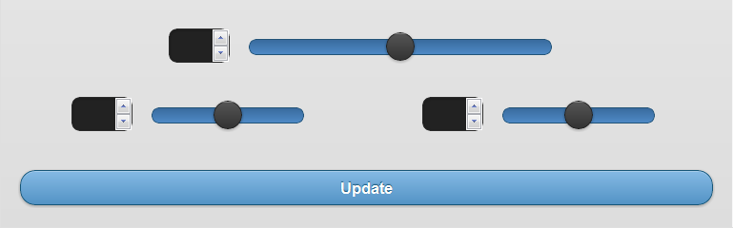
Figure 4.18 CN 3, 4, 6: EOM
CN 3, 4, 6 in Figure 4.18 is the performance of the eye movement of both sides. The doctor can slide the top slider bar  to fill in the same values of both eyes or the slider bars on the right and left to fill in the different values of eye movement on each side.

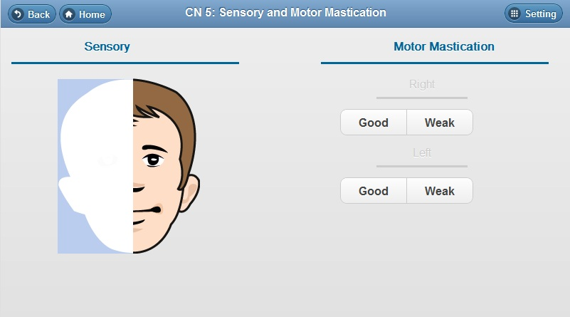
Figure 4.19 CN 5: Sensory and motor mastication
CN 5 in Figure 4.19 shows the sensation of the face and innervates the muscles of mastication. In the sensory section, the doctor can select the abnormal position of the face. In the motor mastication, the doctor can choose the patient’s symptom in both sides.
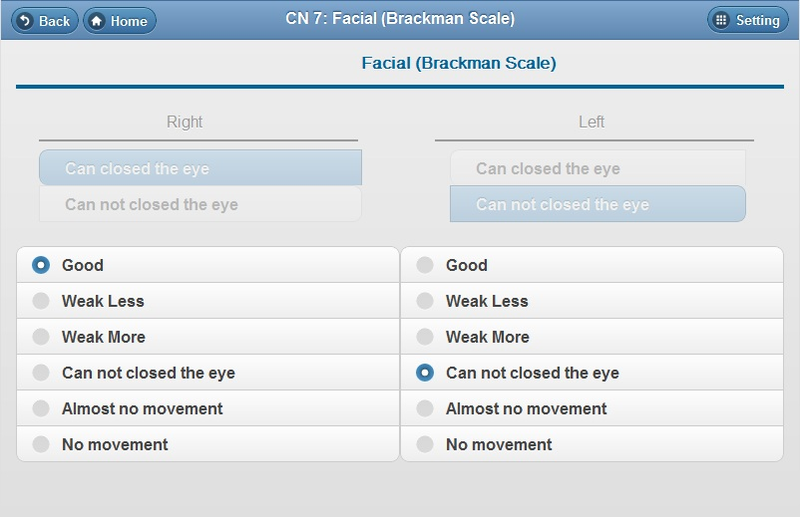
Figure 4.20 CN 7: Facial (Brackman scale)
CN 7 in Figure 4.20 is the motor innervation to the muscles of facial expression. The doctor can choose the patient’s symptom in both sides.
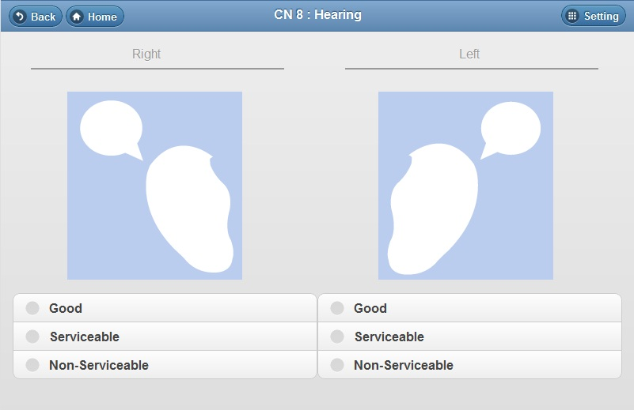
Figure 4.21 CN 8: Hearing
CN 8 in Figure 4.21 is about the senses of sound, rotation, and gravity. The doctor can choose the patient’s symptom in both sides.
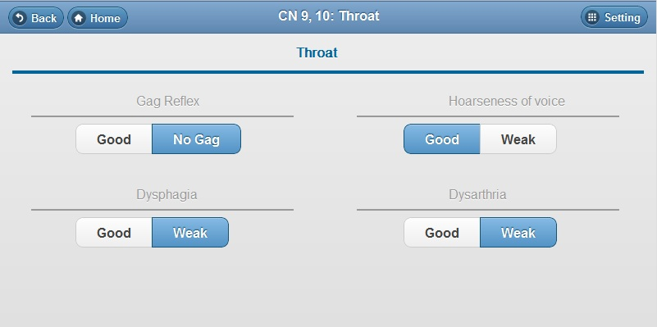
Figure 4.22 CN 9, 10: Throat
CN 9, 10 in Figure 4.22 is the muscle control of voice, resonance, and the soft palate. It consists of four sections. The doctor can choose the symptom from the given choices.

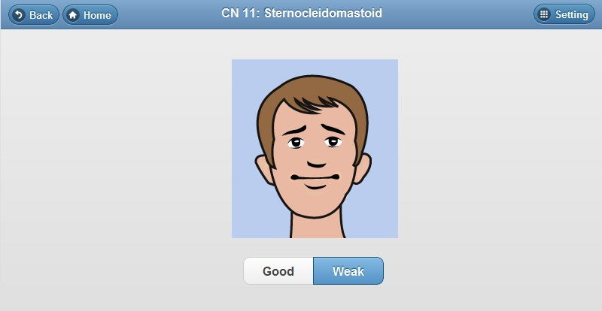
Figure 4.23 CN 11: Sternocleidomastoid
CN 11 in Figure 4.23 is about the control of sternocleidomastoid and trapezius muscles. The doctor can choose either good or weak symptom from the given choices.
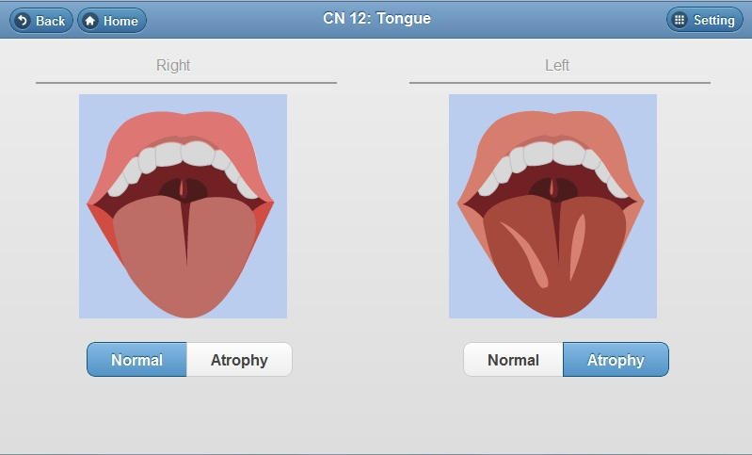
Figure 4.24 CN 12: Tongue
CN 12 in Figure 4.24 is about the motor innervation to the muscles of the tongue. The doctor can select either normal or atrophy symptom from the given choices.
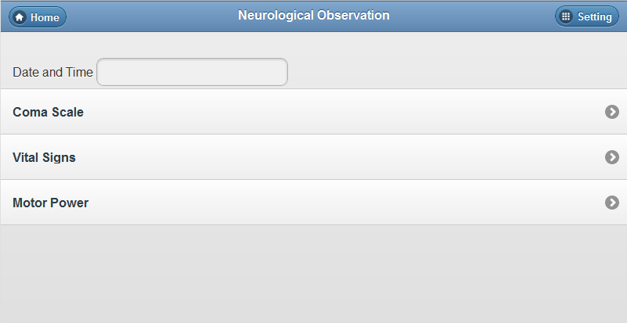
Figure 4.25 Main page of neurological observation
Figure 4.25 shows the other function of the web application which is used in recording the neurological observation symptoms. It consists of three main functions which are coma scale, vital signs, and motor power. The doctor needs to select date and time before recording the symptoms.
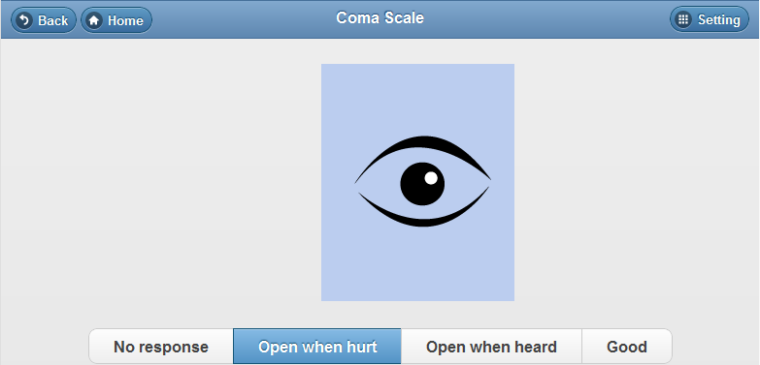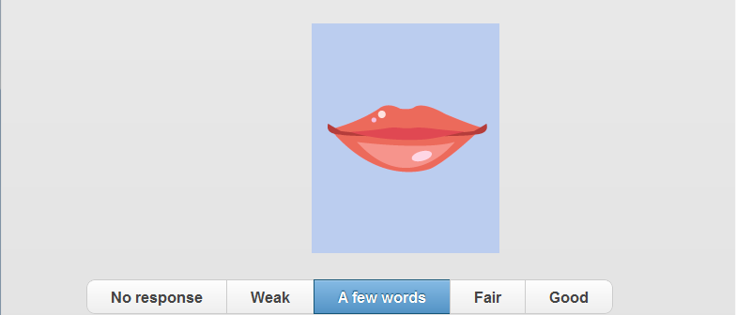
Figure 4.26 Coma scale
Coma scale in Figure 4.26 is used in recording the conscious state of a person from the beginning to subsequent assessment. The doctor can choose the given choices of patient’s symptom.
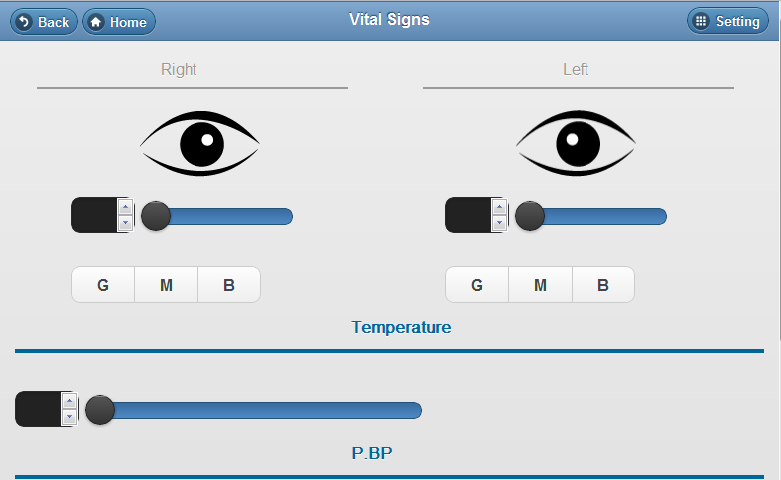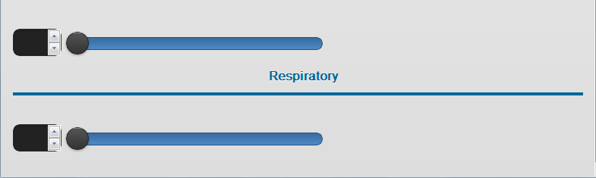
Figure 4.27 Vital signs
Vital signs in Figure 4.27 is used in recording the body temperature, pulse rate (or heart rate), blood pressure, and respiratory rate. The doctor can slide the slider bars and select radio buttons to record the values.

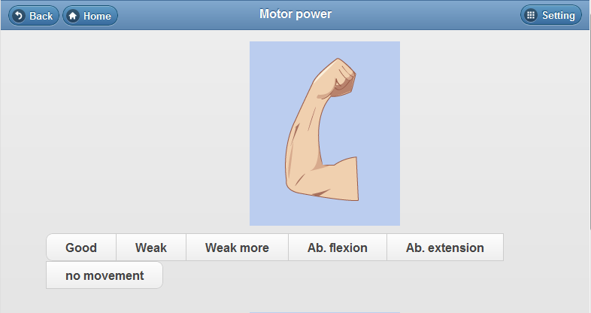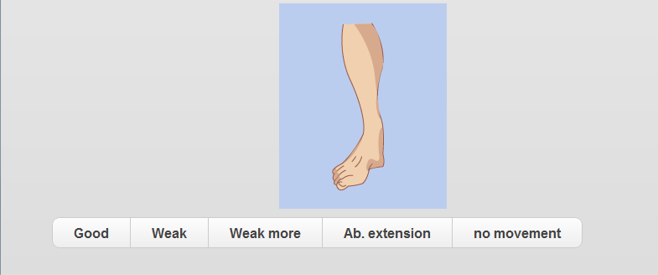
Figure 4.28 Motor power
Motor power in Figure 4.28 is used in recording the movement of arms and legs. The doctor can select the patient’s symptom from the given choices.

4.3 Administrator Interface
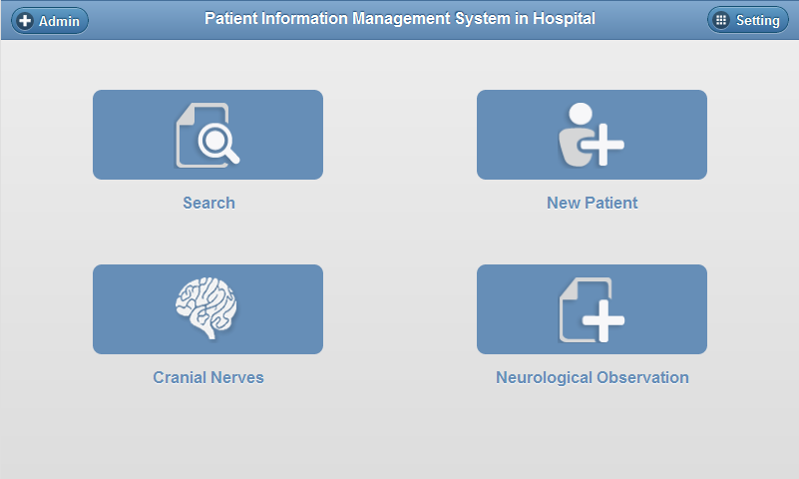
Figure 4.29 Administrator setting
Figure 4.29 shows the index page of the web application when the doctor logs into the system as the administrator, the admin button appears on the navigation bar which enables the administrator to add new users (doctors) into the system. It also shows the main functions of the web application which are search, new patient, cranial nerves, neurological observation, and user setting button on the right side of menu bar. When the administrator presses on an admin button on the menu bar, the system will link to the search doctor’s page where the administrator can search for a doctor or add a new doctor into the system shown in Figure 4.30.

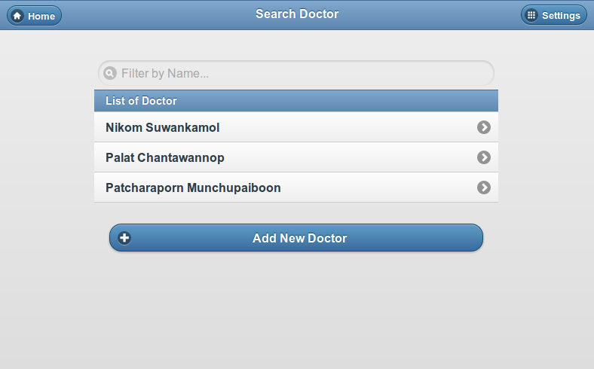
Figure 4.30 View of doctors list
Figure 4.30 shows the lists of doctors who can use the system. The administrator can press the link in order to show the doctors’ profiles as shown in Figure 4.31. In this page, the administrator can add new doctors to the lists by pressing on Add New Doctor button.
Figure 4.31 Doctor’s information page

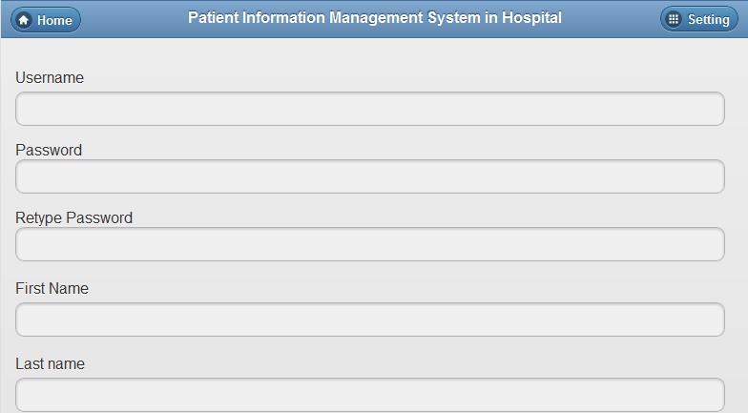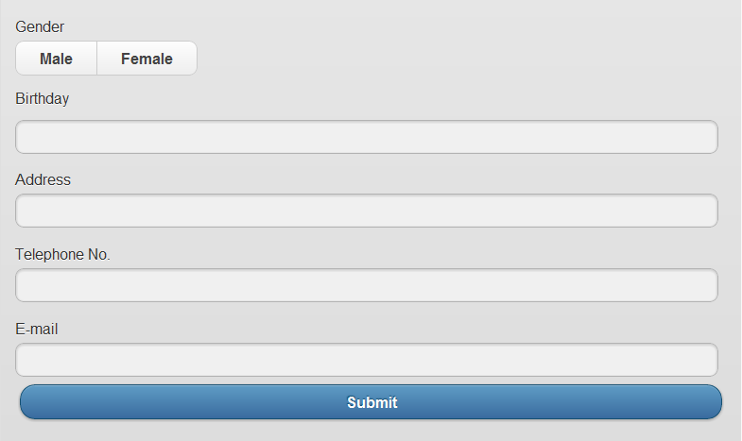
Figure 4.32 Create the new doctor’s profile
Figure 4.32 shows a form to create a new doctor’s profile.
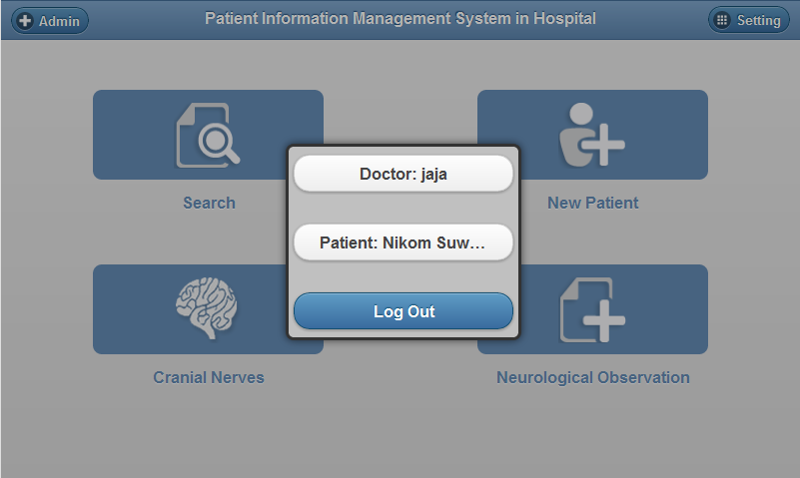
Figure 4.33 Setting.
The setting button on the menu bar in Figure 4.33 shows the doctor’s name, patient’s name, and log out button to log out from the system. The administrator can edit his or her profile as shown in Figure 4.34.
Figure 4.34 View of administrator’s information

